Game Report Document

Name of Game: One man, Fireman

Team Members:

Matthew George Uy Ang (Team Leader)

Chen Qing Bing

Ling Guan Yu

Liu Hao

* Game Idea/ Concept
  + Game Idea: Randomly generated map, with an objective to complete and a high score recorder
  + Game Concept: Top down auto-scroller game
* Project Schedule & Timeline of Task Breakdown

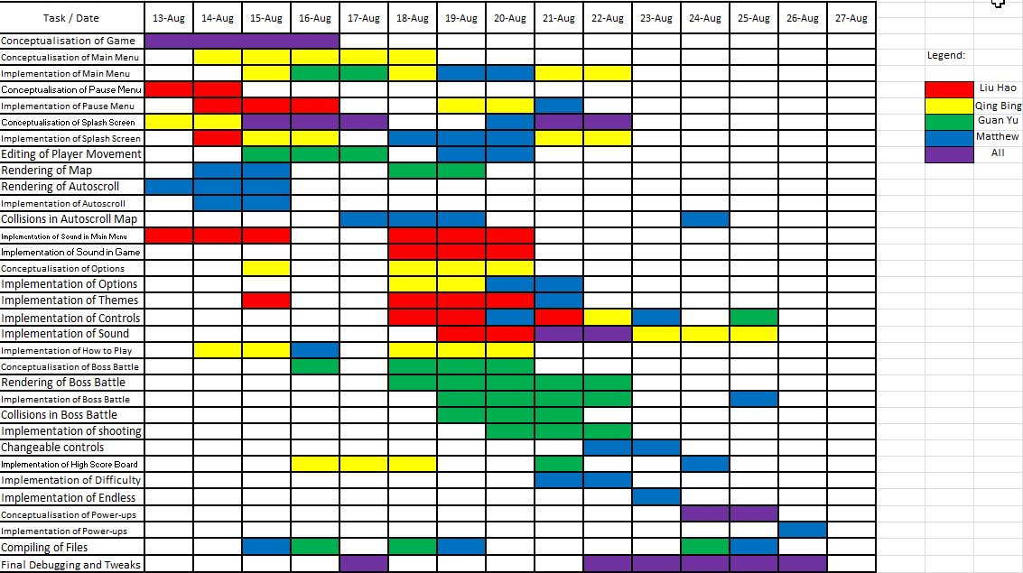

* Screenshots

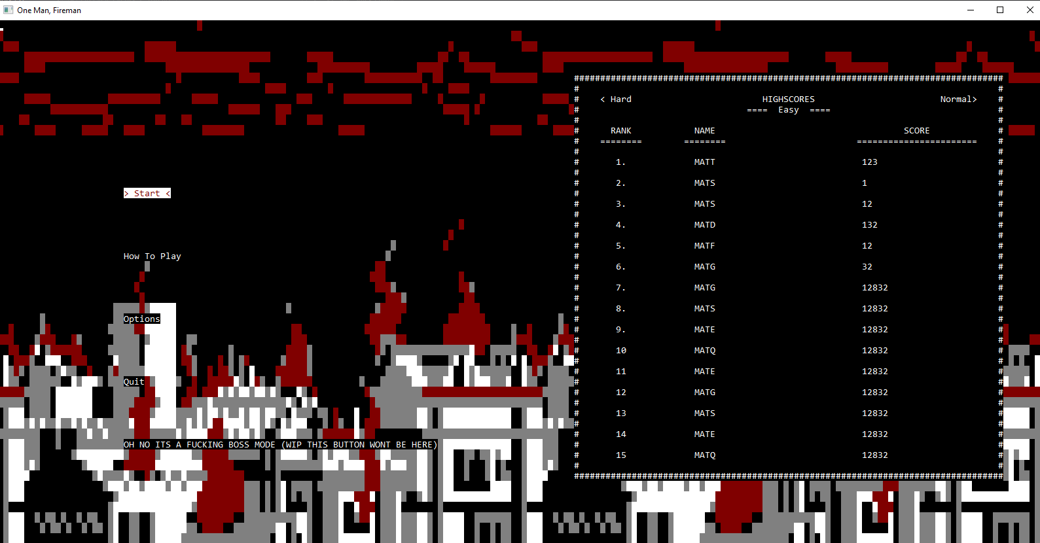

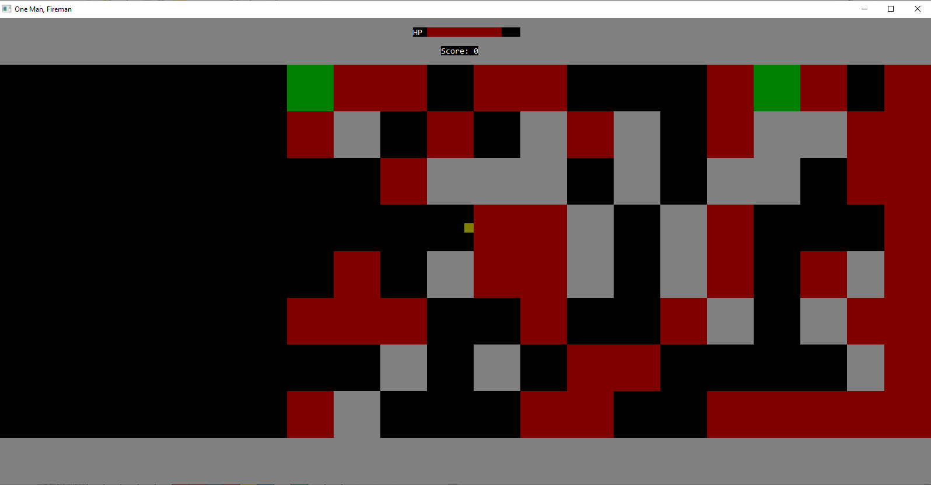

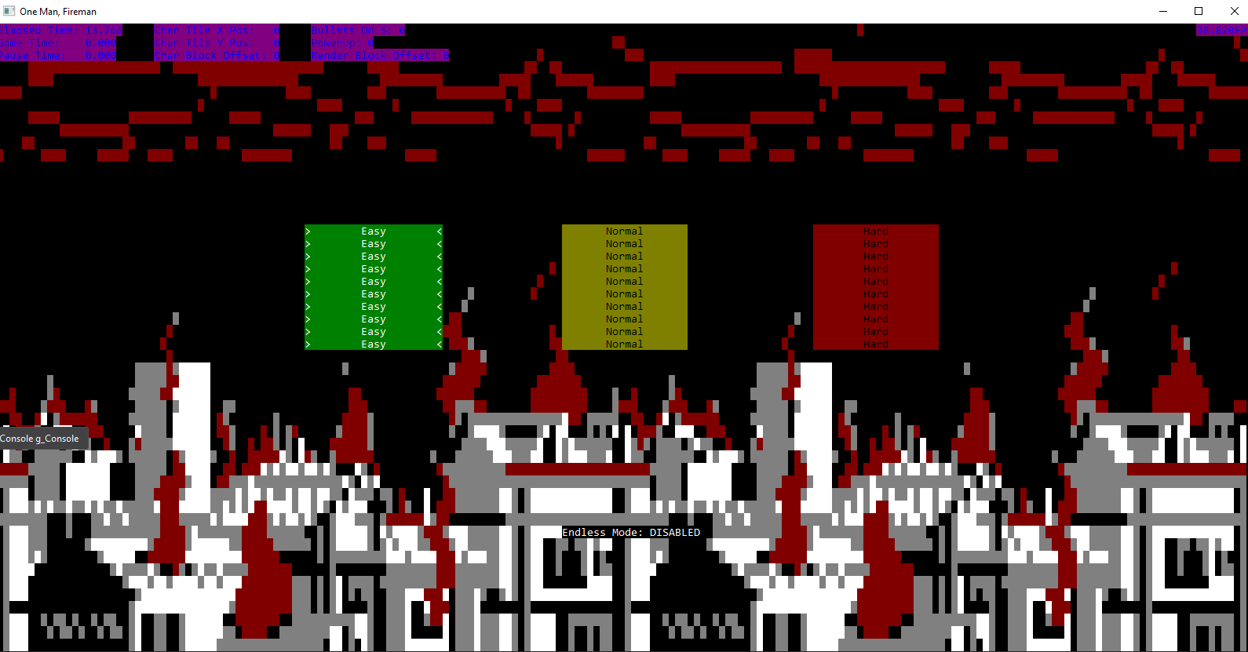

* Description of Features
  + Toggleable Debug Screen
    - Turns on and off the debug screen which shows info that is normally behind the scenes such as the FPS (Frames Per Seconds), the number of bullets initialized, block offset comparator and the tile exposition of the character (Player).
  + Navigable Menu
    - Simple, clean and easy to control menu, which allows the player to change certain settings to their preference, understand the game to a more extensive extent and most importantly, play the game.
  + Objective Markers
    - Objective Markers, which in our games referred to as ‘civilians’, is an objective to strive for as it serves two fundamental purposes. One, it helps to restore the player's health if they are damaged. Secondly, saving civilians contributes to the player’s final score.
  + Power-ups
    - Power-ups will obtain power-ups after every 50 seconds that they survive. They can be used at any time except when against the boss.
    - The power-ups available currently are:
      * Shield
        + Gives the player Invincibility for a period of time
      * Health Pack
        + Restores a player back to full health.
      * Soft Toy
        + Gives the player an add-on score bonus
  + Boss
    - Encountered after surviving a certain period of time.
    - Game is completed when the boss is defeated.
    - Boss shoots fire at player in 3 directions.
    - Boss has 1000(?) health.
* Knowledge applied
  + Use of Pointers
  + Use of Arrays
  + Use of Struct
  + Use of Functions
  + Use of Statements such as ‘if else statement’
  + Use of loops such as ‘while loop’
  + Loading of data from text files
  + Use of version control system (github.com)
* Problems Encountered
  + Getting the physics relating to multiple moving objects was very difficult to solve
  + Getting the menu to not glitch out when specific button is pressed
* Problems Solved
  + Trial and Error resulted in finding error and solution was found
  + Adding in of bounce time at the start and the end prevented error from happening
* Lessons Learnt
  + Time management
* Future Enhancements/Improvement
  + Mini Games
  + Additional Power-ups